TC041C12W00 / U00

Features:
- Based on T5L1, running DGUS II system.
- 4.1 inch, 720*720 pixels resolution, 16.7 M colors, IPS-TFT-LCD, wide viewing angle.
- In-cell full lamination Capacitive Touch Panel, beautiful appearance and reliable structure.
- RS485 communication, 4Pin_2.0mm interface; proximity sensor, no temperature

detection, wire controller.
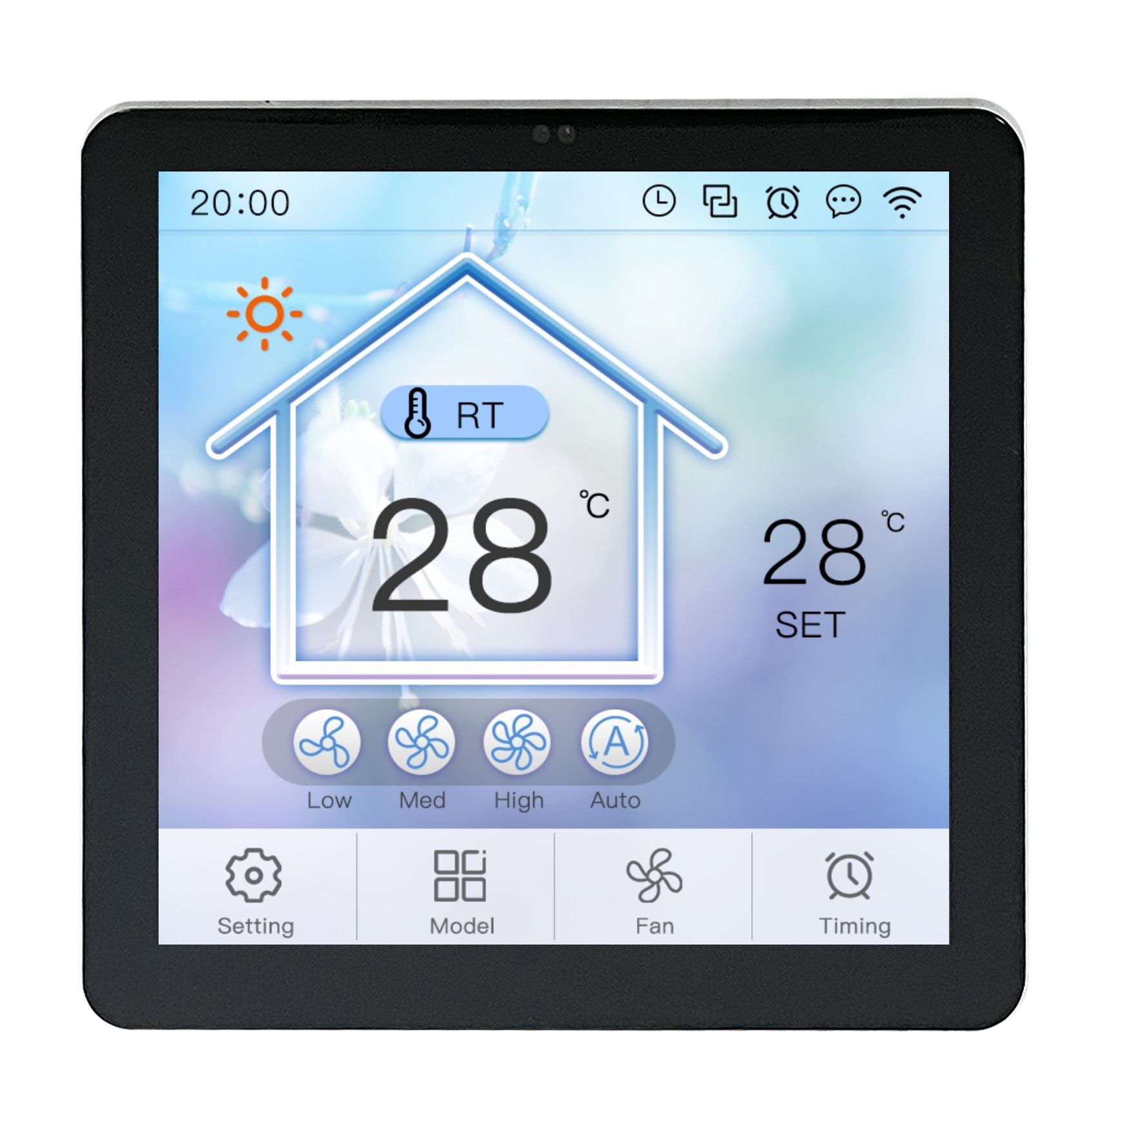
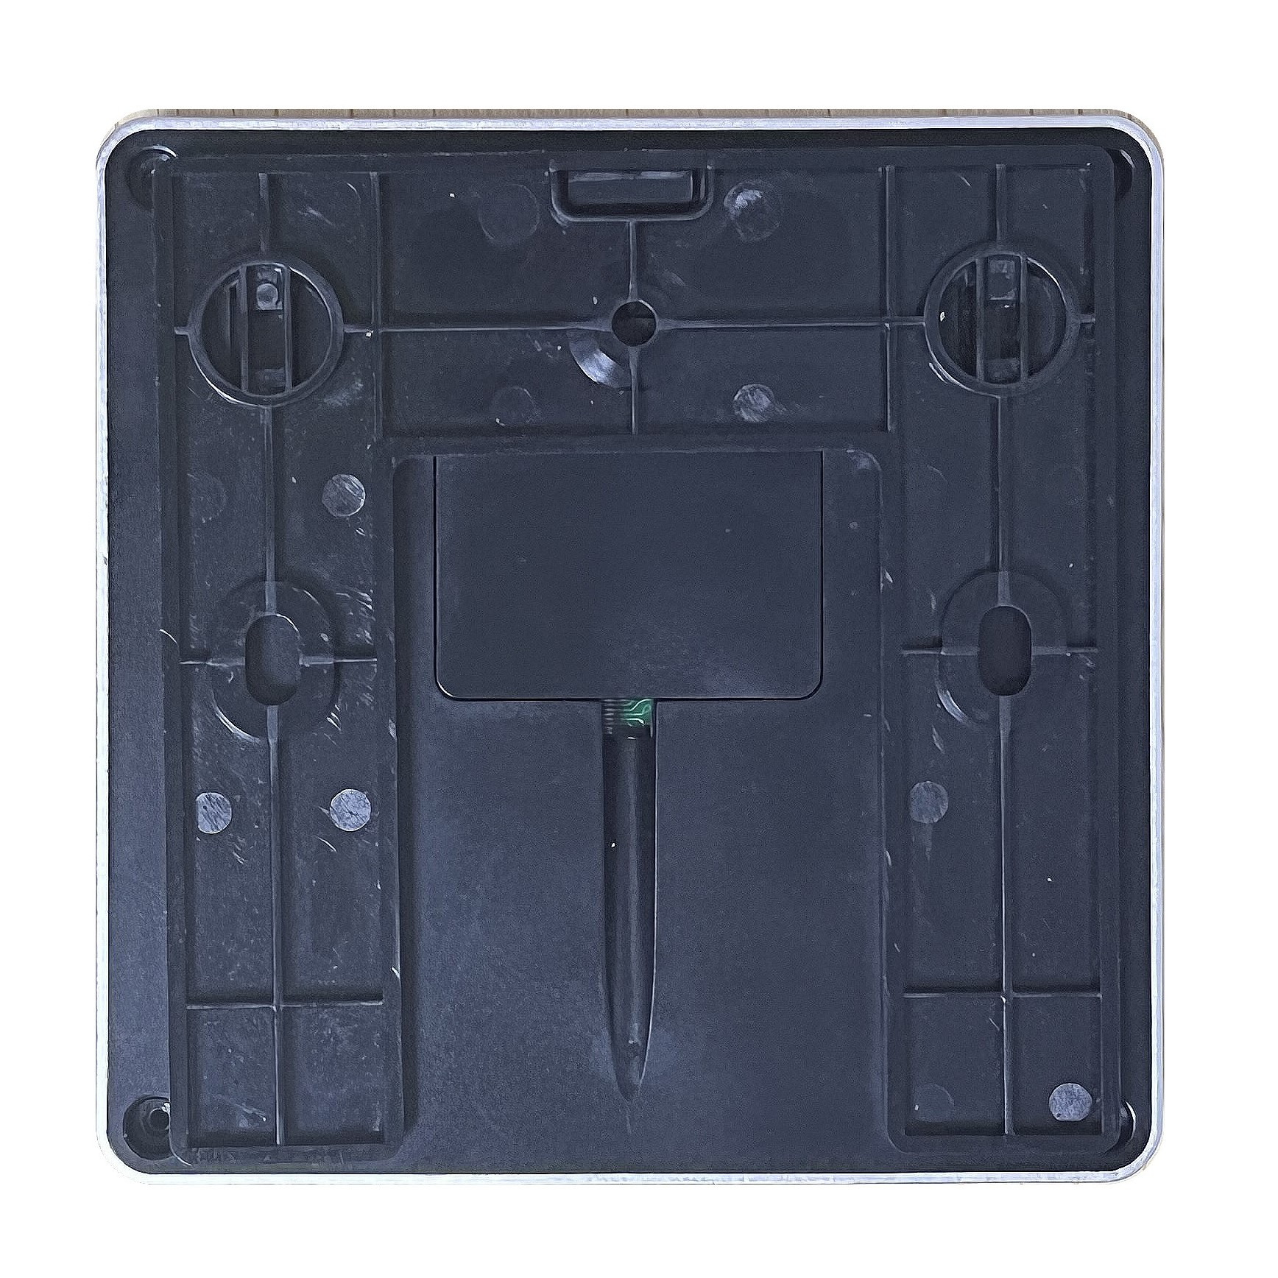

1 Hardware and Interface

1.1 Hardware and Interface Description
No. | Name | Description
1 | T5L1 ASIC | Developed by DWIN. Mass production in 2019,1MBytes Nor Flash on the chip, 512KBytes used to store the user database. Rewrite cycle: over 100,000 times
2 | LCM interface | FPC40_0.5mm,MIPI interface
3 | CTP interface | FPC2_1.25mm,IIC interface
4 | User Interface | For power supply and serial communication, 4Pin_ 2.0mm seat
5 | Flash | 16MBytes NOR Flash, for fonts, pictures and audio files.  Rewrite cycle: over 100,000 times
6 | Speaker | On-board speaker. Rated power: 1W
7 | RTC | Super-capacitor for power supply. Accuracy: ±20ppm @25℃. It can work normally for 7 days after power failure.
8 | WIFI Module | TC041C12W00:Built-in WIFI-10 module  TC041C12U00:None
9 | SD card interface | FAT32. Download files by SD card interface can be displayed in statistics. Download rate: 4Mb/s

2 Specification Parameters

2.1 Display Parameters
LCD Type | IPS, TFT LCD
Viewing Angle | Wide viewing angle, 85°/85°/85°/85° (L/R/U/D)
Resolution | 720*720 pixels (0°/90°/180°/270°)
Color | 24-bit 8R8G8B
Active Area (A.A.) | 74mm (W) * 74mm (H)
Backlight Mode | LED
Backlight Service Life | >20000 hours (Time of the brightness decaying to 50% on the condition of continuous working with the maximum brightness)
Brightness | 300nit
Brightness Control | 0~100 grade (When the brightness is adjusted to 1%~30% of the maximum brightness, flickering may occur and is not recommended to use in this range)
Note: You can use dynamic screen saver wallpapers to avoid afterimages caused by fixed page display for a long time.

2.2 Touch Parameters
Touch Type | CTP (Capacitive Touch Panel)
Structure | In-cell (Without Cover Lens)
Touch Mode | Finger, up to 2 touches simultaneously.
Light Transmittance | Over 90%
Life | Over 1,000,000 times touch

2.3 Interface Parameters
Mode | RS485
Voltage Level | Test Condition | Min | Typ. | Max | Unit
Voltage Level | Output 1 | 2.5 | 5.0 | - | V
Voltage Level | Output 0 | - | -5.0 | -2.5 | V
Voltage Level | Input 1 | 0 | 2.5 | - | V
Voltage Level | Input 0 | - | -2.5 | -0.2 | V
Baud Rate | 3150~3225600bps, typical value of 115200bps
Interface Cable | 4Pin_2.0mm

2.4 Electrical Specifications
Rated Power | <5W
Operating Voltage | 6.5~36.5V, typical value of 12V
Operating Current | 270mA | VCC=12V, max backlight
Operating Current | 200mA | VCC=12V, backlight off
Recommended power supply: 12V 0.5A DC

2.5 Environment
Operating Temperature | -10℃~60℃
Storage Temperature | -20℃~70℃
Operating Humidity | 10%~90%RH, typical value of 60% RH

3 Reliability Test
Before mass production of smart screens, a series of procedural reliability tests need to be conducted according to actual application requirements and product specification control standards to ensure product quality.

3.1 ESD Test
Test temperature: 25°C
Test process: the product was placed on the test bench to perform contact and air discharge in turn of the serial screen iron frame and display area. During the experimental process, it was observed whether the screen is dead, black, white, splash, or reboot. According to the experiment results, the performance is in line with the criteria GB/T 17626.2 B level and above.
Discharge Type | Discharge Value | Result
Contact discharge | ±4KV | Normal operation
Air discharge | ±4KV | Normal operation

3.2 High and Low Temperature Test
Test temperature:-10~60℃
Test process: the product will be placed obliquely in the high and low temperature test chamber for 12h for 20 on and off cycles. Then it will be check at room temperature after power on for the appearance and function, CTP offset situation, jumping point, page random switching and failure.
Temperature | Result
High temperature(60℃) | Normal operation
Low temperature(-10℃) | Normal operation

4 Packing Capacity & Dimension
Dimension
Dimension | 88(W) *88(H) * 16.1(T) mm
Net Weight | 111g
Packing Capacity
Model | Dimension | Layer | Quantity/Layer | Quantity (Pcs)
Carton1: | 220mm(L)*160mm(W)*47mm(H) | 1 | 2 | 2
Carton2: | 250mm(L)*200mm(W)*80mm(H) | 2 | 2 | 4
Carton3: | 320mm(L)*270mm(W)*80mm(H) | 2 | 4 | 8
Carton4: | 450mm(L)*350mm(W)*300mm(H) | - | - | -
Carton5: | 600mm(L)*450mm(W)*300mm(H) | 1 | 56 | 56

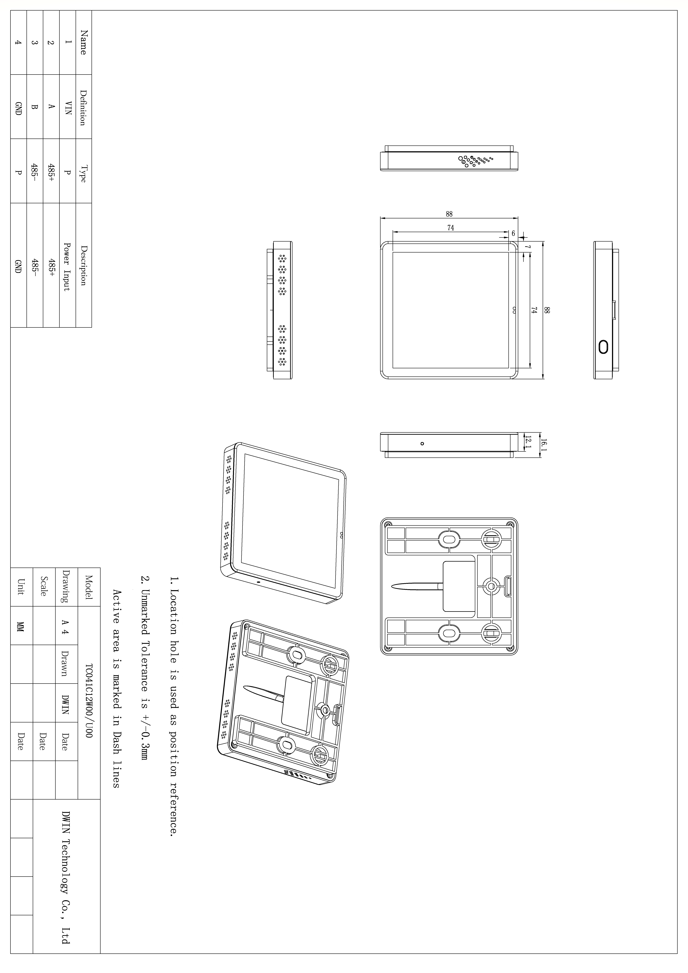

5 T5L series IC features
(1)Mature and stable 8051 core which is the most widely used with the maximum operating frequency of T5L is up to 250MHz, 1T(single instruction cycle)high speed operation.
(2)Separate GUI CPU Core running DGUS II System:
- High-speed display memory, 2.4GB/S bandwidth.
- 2D hardware acceleration, the decompression speed of JPEG is up to 200fps@1280*800 and the UI with animation and icons as its main feature is extremely cool and smooth.
- Images and icons stored in JPEG format. Adopt Low-cost 16Mbytes SPI Flash.
- Support CTP or RTP with adjustable sensitivity and maximum 400 Hz touch frequency.
- 1-way 15bit 32Ksps PWM digital power amplifier driver loudspeaker, save power amplifier cost and achieve high signal-to-noise ratio and sound quality restoration.
- 128Kbytes variable storage space for exchanging data with OS CPU Core and memory.
- Support DGUS development and simulation on PC. Support background remote upgrade.
(3)Separate CPU (OS CPU) core runs user 8051 code or DWIN OS system and user CPU is omitted in practical application:
- Standard 8051 architecture and instruction set, 64Kbytes code space, 32Kbytes on-chip RAM.
- 64 bit integer mathematical operation unit (MDU), including 64 bit MAC and 64 bit divider.
- 28 IOs, 4-channel UARTs, 1-channel CAN, up to 8-channel 12-bit A/Ds and 2-channle 16-bit PWM of adjustable resolution.
- Support IAP on-line simulation and debugging with unlimited number of breakpoints.
- Upgrade code online through DGUS system.
(4)1Mbytes on-chip Flash with DWIN patent encryption technology ensure code and data security.
(5)Operating temperature ranges from -40℃ to +85℃ (IC operating temperature customizable from -55℃ to 105℃).

DWIN encourages users to design your own customized product based on T5L.

6 Installation Schematic

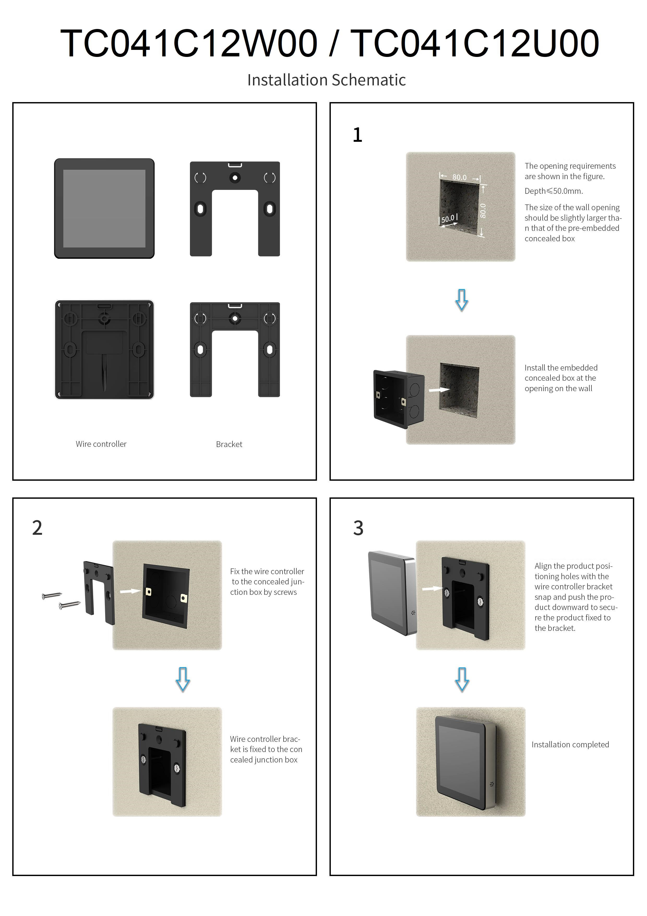

7 Record History
Rev | Date | Content | Editor
00 | 2023-07-10 | First Edition | YML

Disclaimer: The product design is subject to alternation and improvement without prior notice.

Please contact us if you have any questions about the use of this document or our products, or if you would like to know the latest information about our products:
Customer service Tel: +86-400-018-9008
Customer service E-mail: dwinhmi@dwin.com.cn
Website: www.dwin-global.com
DWIN Developer Forum: https://forums.dwin-global.com/index.php/forums
Thank you all for continuous support of DWIN, and your approval is the driving force of our progress!

